**MOBILE BANKING APPLIACATIONS**

**Overview:**

Mobile banking applications are software programs developed by financial institutions that allow customers to conduct various financial transactions and access banking services through their smartphones or tablets. These apps are typically available on both iOS and Android platforms.

**Features of Mobile Banking Apps:**

**1. Account Management:**

**- Balance Check:** Users can check their account balances in real-time.

**- Transaction History:** View recent transactions and account statements.

**- Fund Transfers:** Transfer money between accounts or to other people, both domestically and internationally.

**- Bill Payments:** Pay utility bills, credit card bills, and other expenses.

**- Mobile Check Deposit:** Deposit checks by taking a photo with the smartphone camera.

**2. Security Features:**

**- Multi-Factor Authentication (MFA):** Enhance security by requiring two or more verification methods.

**- Biometric Authentication:** Use fingerprint or facial recognition for logging in.

**- Real-Time Alerts:** Receive notifications about suspicious activities, low balances, and large transactions.

**- Encryption:** Data encryption ensures that sensitive information is protected during transmission.

**3. User Experience:**

**- User-Friendly Interface:** Intuitive design for easy navigation.

**- Personalization:** Customizable features such as setting up recurring payments or alerts.

**- Customer Support:** In-app customer service chatbots or direct messaging with bank representatives.

**4. Additional Services:**

**- Investment Services:** Access to stock trading, investment portfolios, and financial planning tools.

**- Loan Services:** Apply for personal loans, mortgages, or credit lines directly through the app.

**- Budgeting Tools:** Tools for tracking spending, budgeting, and setting financial goals.

**- Rewards and Offers:** Special offers, discounts, and rewards for using the app.

**Benefits of Mobile Banking:**

**- Convenience:** Banking anytime and anywhere without the need to visit a physical branch.

**- Time-Saving:** Quick execution of transactions and other banking activities.

**- Cost-Effective:** Reduced need for paper statements and lower operational costs for banks.

**- Enhanced Financial Management:** Real-time access to account information helps customers manage their finances more effectively.

**Challenges and Concerns:**

**1. Security Risks:** Despite advanced security measures, mobile banking apps are still susceptible to cyber threats, such as phishing attacks, malware, and data breaches.

**2. Technical Issues:** Bugs, crashes, and compatibility issues can affect the user experience.

**3. Privacy Concerns:** Handling of personal and financial data raises privacy concerns among users.

**4. Digital Divide:** Not all customers are tech-savvy, and some may lack access to smartphones or reliable internet services.

**Regulatory and Compliance Aspects:**

Mobile banking applications in the U.S. must comply with various regulations to ensure security and protect consumer rights. Key regulations include:

**- Gramm-Leach-Bliley Act (GLBA):** Requires financial institutions to explain their information-sharing practices and safeguard sensitive data.

**- Dodd-Frank Act:** Includes provisions for consumer protection in financial services.

- Federal Financial Institutions Examination Council (FFIEC) Guidelines: Provides guidelines for online banking security.

**- Bank Secrecy Act (BSA):** Requires financial institutions to help prevent money laundering.

**Future Trends:**

**1. Artificial Intelligence (AI) and Machine Learning (ML):** Enhancing personalization, customer service, and fraud detection.

**2. Blockchain Technology:** Potential use for secure and transparent transactions.

**3. Voice Banking:** Integration of voice assistants for conducting banking transactions.

**4. Augmented Reality (AR):** Providing interactive and immersive banking experiences.

**5. Open Banking:** Sharing of financial data with third-party developers for creating new financial services and products.

**Popular Mobile Banking Apps in the U.S.:**

**1. Bank of America Mobile Banking:** Offers a comprehensive suite of banking services, robust security features, and AI-driven insights through the Erica assistant.

**2. Chase Mobile:** Provides easy access to accounts, Chase QuickDeposit, and various investment services.

**3. Wells Fargo Mobile:** Features include check deposits, transfers, bill pay, and FICO score access.

**4. Citi Mobile:** Offers a wide range of services including investments, personalized insights, and global transfers.

**5. Capital One Mobile:** Known for its user-friendly interface, card management, and account monitoring.

**Data for mobile banking applications (2019-2023):**

**Number of Mobile Banking Users (in millions)**

|  |  |
| --- | --- |
| **Year** | **Number of Users (in millions)** |
| 2019 | 125 |
| 2020 | 140 |
| 2021 | 160 |
| 2022 | 180 |
| 2023 | 200 |

**Transaction Volumes (in billions USD)**

|  |  |
| --- | --- |
| **Year** | **Transaction Volume (in billions USD)** |
| 2019 | 1.5 |
| 2020 | 2.0 |
| 2021 | 2.8 |
| 2022 | 3.5 |
| 2023 | 4.2 |

**Adoption Rates (% of Total Banking Customers)**

|  |  |
| --- | --- |
| **Year** | **Adoption Rate (%)** |
| 2019 | 35 |
| 2020 | 40 |
| 2021 | 45 |
| 2022 | 50 |
| 2023 | 55 |

**Customer Satisfaction (Average Rating out of 5)**

|  |  |
| --- | --- |
| **Year** | **Adoption Rate (%)** |
| 2019 | 4.0 |
| 2020 | 4.2 |
| 2021 | 4.3 |
| 2022 | 4.4 |
| 2023 | 4.5 |

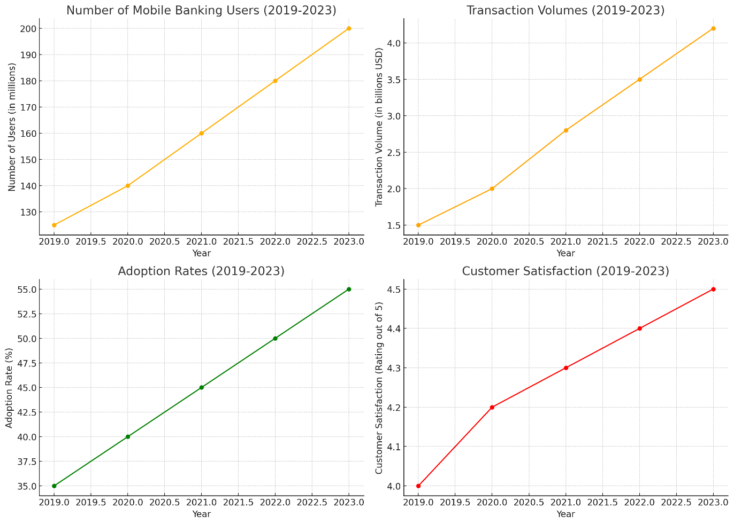

**Interpretation of the graphs:**

**1. Number of Mobile Banking Users (2019-2023)**

The graph illustrates a steady increase in the number of mobile banking users from 2019 to 2023. Starting at 125 million users in 2019, the number grew to 200 million by 2023. This significant growth indicates the rising popularity and adoption of mobile banking services, driven by the increasing reliance on digital solutions for financial transactions and the convenience offered by mobile banking apps.

**2. Transaction Volumes (2019-2023)**

The graph shows a marked rise in transaction volumes conducted via mobile banking apps from 2019 to 2023. Transaction volumes increased from $1.5 billion in 2019 to $4.2 billion in 2023. This trend reflects the growing trust and dependence on mobile banking for various financial activities, highlighting the sector's expansion and the increasing integration of mobile banking into daily financial operations.

**3. Adoption Rates (2019-2023)**

This graph indicates the adoption rates of mobile banking as a percentage of total banking customers. Adoption rates rose from 35% in 2019 to 55% in 2023, showcasing the widespread acceptance of mobile banking. This upward trend underscores the transition towards digital banking platforms, driven by their convenience, efficiency, and enhanced user experience, alongside a broader shift in consumer behavior towards digital-first solutions.

**4. Customer Satisfaction (2019-2023)**

The graph reveals an improvement in customer satisfaction ratings for mobile banking apps from 2019 to 2023. The average rating increased from 4.0 to 4.5 out of 5, indicating growing user contentment with the features, security, and usability of mobile banking applications. This positive trend suggests that banks have successfully addressed user needs and concerns, enhancing the overall mobile banking experience.

**Conclusion:**

Mobile banking applications have revolutionized the banking experience in the U.S. by offering unparalleled convenience and a wide array of services. As technology continues to evolve, these apps are expected to become even more sophisticated, providing enhanced features and security to meet the growing demands of tech-savvy consumers. However, banks must continue to address security and privacy concerns to maintain customer trust and ensure the safe use of mobile banking services.